**Faculty of Engineering and Technology**

**Electrical and Computer Engineering Department**

**Computer Networks Laboratory ENCS413**

**EXP 3 report**

**Dynamic Routing 1 (Distance Vector Routing Protocols)**

**RIP & IGRP**

**Name : Mohammad Raddad**

**ID : 1180812**

**Instructor : Dr.Mohammad helal**

**Table Of Contents**

**Theory** 5

1.Introduction 5

2.Types of Dynamic Routing 5

3.Routing Information Protocol(RIP) Definition 6

4.RIP Configuration 6

5.Enhanced Interior Gateway Routing Protocol 6

6.EIGRP Configuration 6

**Procedure & Discussion** 7

1.Topology 7

2.Networks IPs 7

3.Configuring RIP Routing 8

4.Verifying the RIP routing tables 8

5.Configuring EIGRP Routing 9

6.Verifying the EIGRP routing tables 9

**Results** 10

1.Verifying the RIP routing tables 10

2.Verifying the EIGRP routing tables 11

**Conclusion** 13

**References** 14

**Abstract:**

The aim of the experiment is to see the advantage of the dynamic routing and it's types and to see if the dynamic routing fix the problem of the static routing and to know how the dynamic types works and to understand Routing Information Protocol (RIP) Interior Gateway Routing Protocol (IGRP),

# **Theory**

**Introduction**

In statistical communication networks, there are several basic routing lessons. The first magnificence is known as the gap vector routing protocol, while the second one is known as the link-country routing protocol. In statistical communication networks, there are several basic routing lessons. The Distance Vector Routing Protocol is the first magnificence, the Link State Routing Protocol is the second, and the Routing Information Protocol (RIP) and Extended Internal Gateway Routing Protocol (EIGRP) utilized in this test are both distance vector routing protocols. This is the protocol. Open Shortest Path First is an instance of another class (OSPF). In the gap vector routing protocol, each node (router) has the most useful routing facts about its neighbors first. Each The router sends routing data to nearby routers on a regular basis. As a consequence, at the end of the operation, each node obtains statistics for the whole community. If a node fails, the neighbor instantly changes the routing statistics and alerts the neighbor, even if it is done in the old-fashioned approach, until all nodes in the community are aware of the change.

**Dynamic routing**

Dynamic routing uses a lot of protocols to find the networks and update or edit them (routing tables ) and of course it's easier than static or default routing but it will cost from control process unit (CPU) and the dynamic routing works by connecting the neighbor routers and there are two types of routing protocol first one is routing information protocol (RIP) and enhanced interior gate way routing (EIGRP)

**Management distance**

The management distance (AD) is a metric that determines how trustworthy routing information received by a router from its peers is. The management distance is a number that ranges from 0 to 255. Where 0 denotes the most trusted route and 255 denotes that it is not used to route traffic. If the router receives two updates identifying the same remote network, the first thing it does is check AD. If one of the advertised routes has a lower AD than the other, the route with the lowest AD is included in the routing table. If both advertised routes to the same network have the same AD, choose the best route to the distant network (of the routing protocol metric (hop count, bandwidth, etc.) line). Protocol metric (hop count, bandwidth, etc.) line) if both advertised routes to the same network have the same AD. Protocol for Routing Information (RIP)

Only hops are used to determine the best path to your network. When RIP detects many links to the same remote network with the same hop count, it performs round-robin load balancing automatically. RIP employs classful subnetting and can load balance up to six Equal cost links (4 by default).

IGRP, you supply the autonomous system number. All routers must use the same number in order to share routing table information. Here is a list of IGRP characteristics that you won’t find in RIP:

IGRP can be used in large Internetworks

IGRP uses an Autonomous System number for activation

IGRP gives a full route table update every 90 seconds

IGRP uses bandwidth and delay of the line as metric (lowest composite metric)

# **Procedure & Discussion**

1. Topology

We connect first network with the neighbor router then the neighbor network with the same router and so on lets have an example

As we see in the picture below these two PCs are in network 0 and the red line is network 1 so the command will be

Network 192.168.0.0

Network 192.168.1.0

Of course we write this command in the router 0

And know I can send the message to router 1

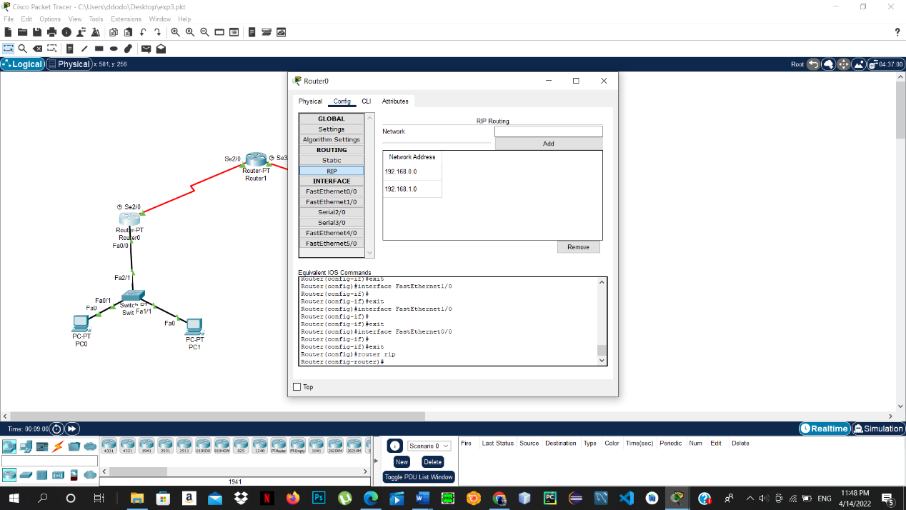

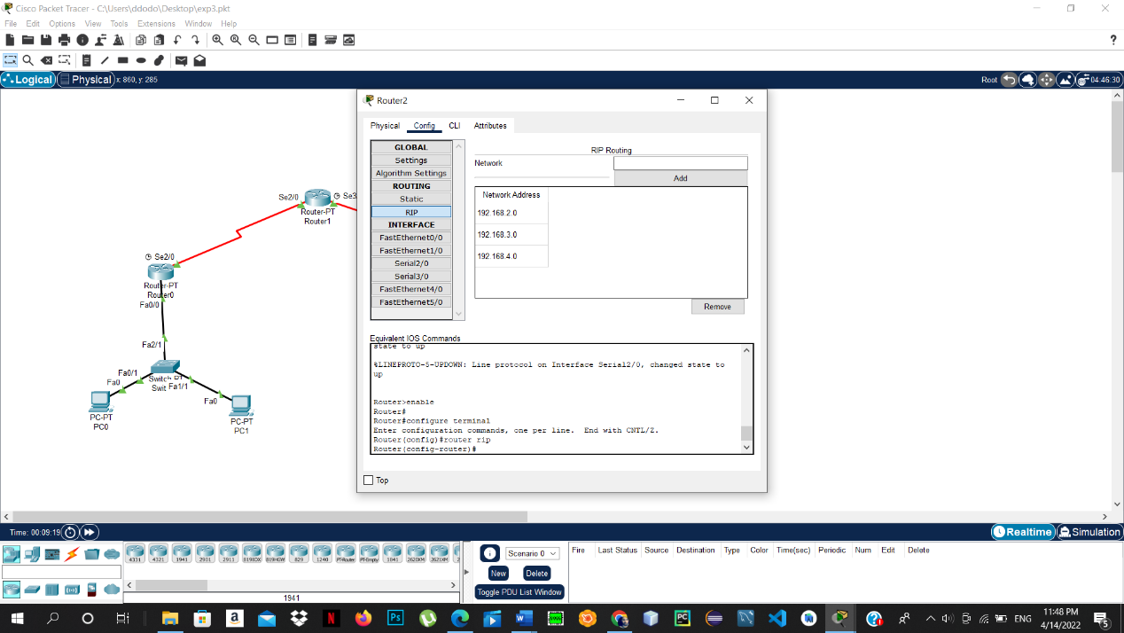

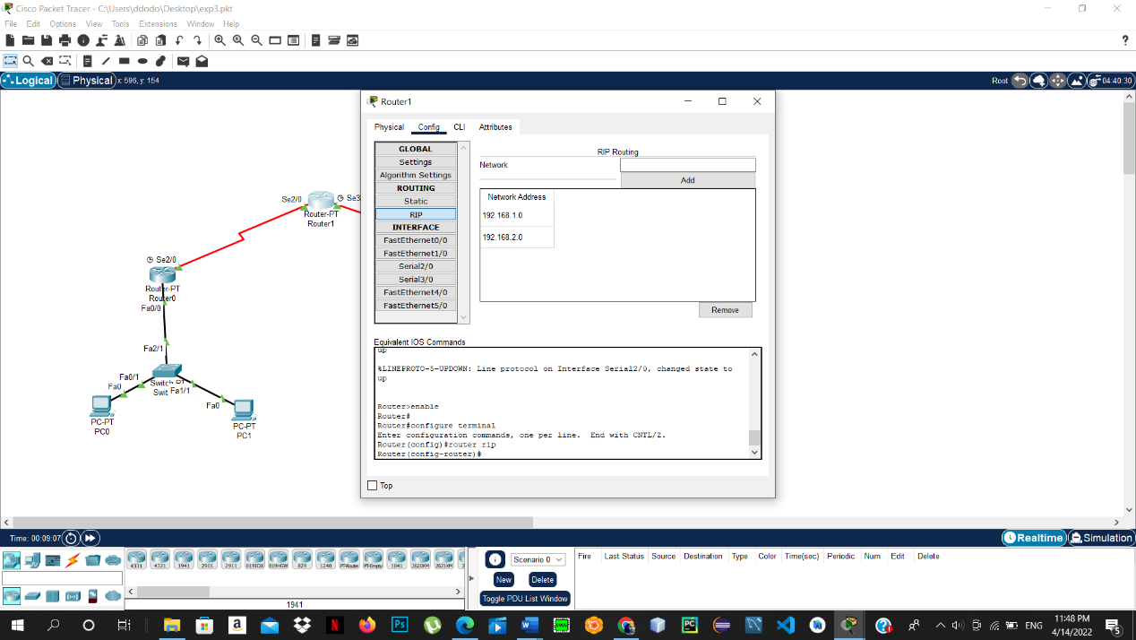

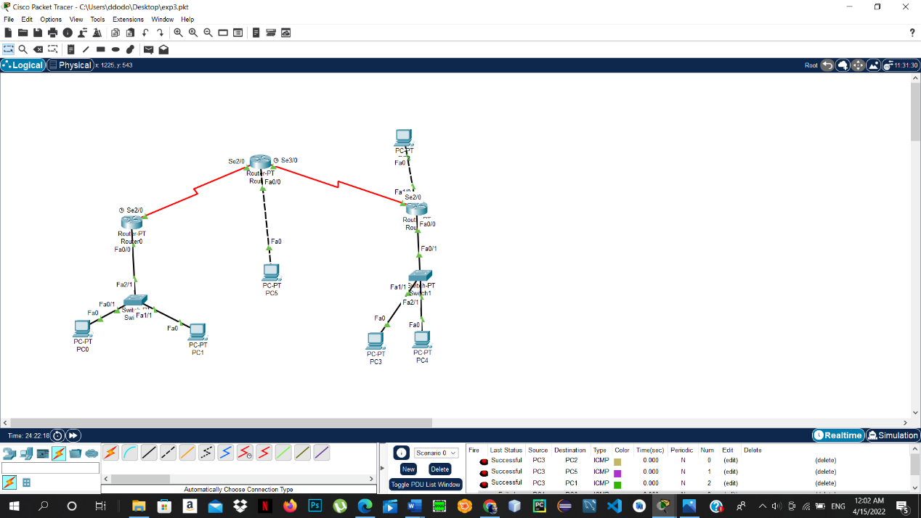

**Conclusion**

In this lab we have learned a useful things and the benefit of dynamic programing and how the Protocol for Routing Information (RIP) and enhanced interior gate way routing (EIGRP) works and the difference between them and how they are better than the static one the we learned the advantage and the disadvantage and how we can routing by using them and how to use them and in the end they are better than the static routing

# **References**

<https://www.geeksforgeeks.org/eigrp-fundamentals/>

<https://ritaj.birzeit.edu/bzu-msgs/attach/2054870/ENCS413Manual.pdf>